**Ex. No.: 6 Date:10.09.2020**

**Design of Half Adder and Full Adder Circuits**

**Aim:**

To get the stimulated waves of half adder and full adder and verify it with theoretical values.

**Apparatus/Tool required:**

ORCAD / PSpice simulator - > **7400 Library – 7408, 7432 & 7486**

**Source Library - Digclock**

Simulation Settings: **Analysis Type - Time Domain**

**Run to time: 4ms (for Half Adder)**

**Run to time: 8ms (for Full Adder)**

**Circuit Diagram:**

**Half – Adder Circuit**



****

**Full – Adder Circuit**



****

****

****

+ A·B

**Theory:**

**Half Adder Circuit:**

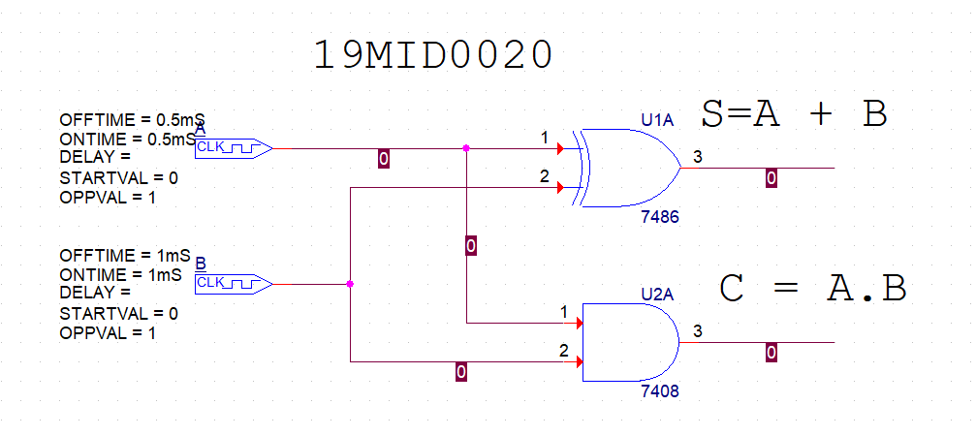

**Truth Table** 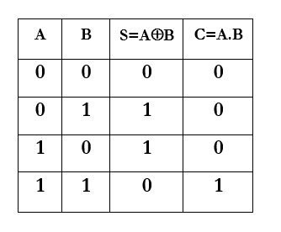

**Full Adder Circuit**

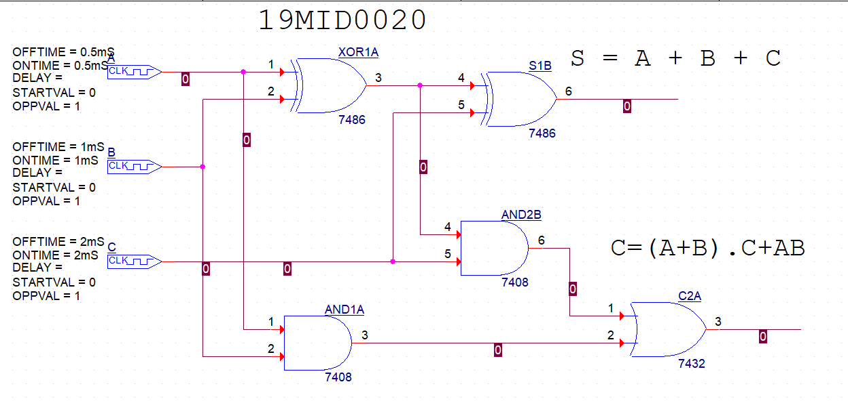

**Truth Table**

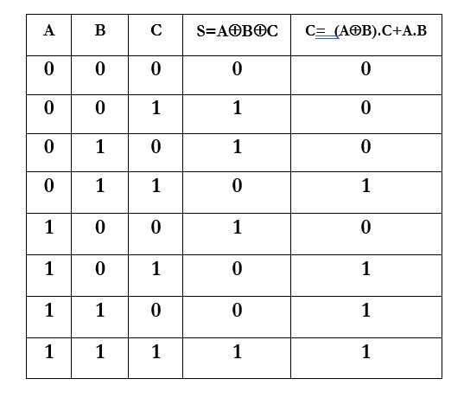

**Simulation Circuit Diagram and Output (Both Waveform and Truth Table):**

**Half – Adder**

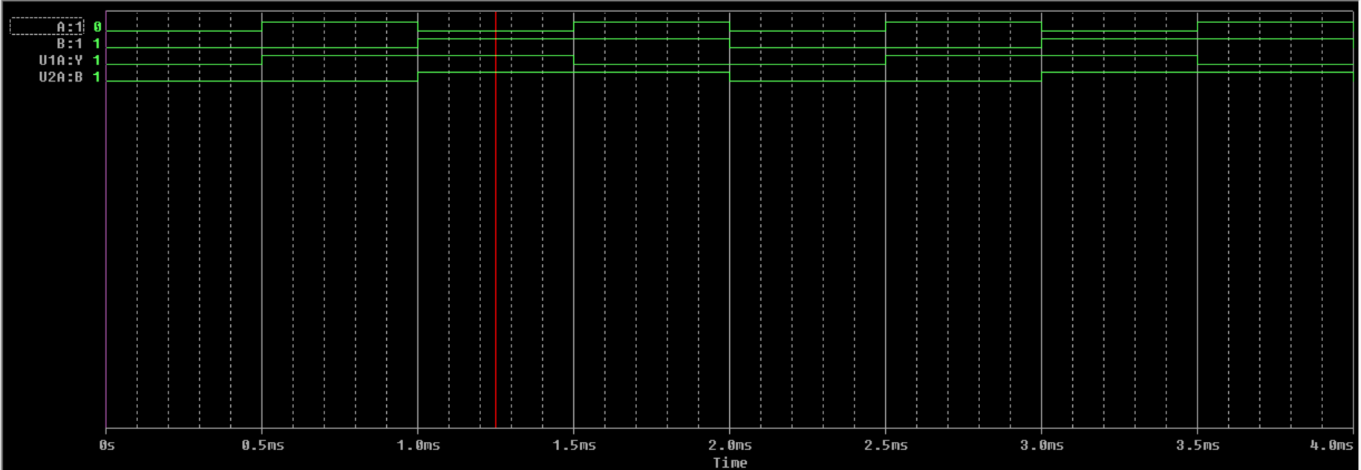

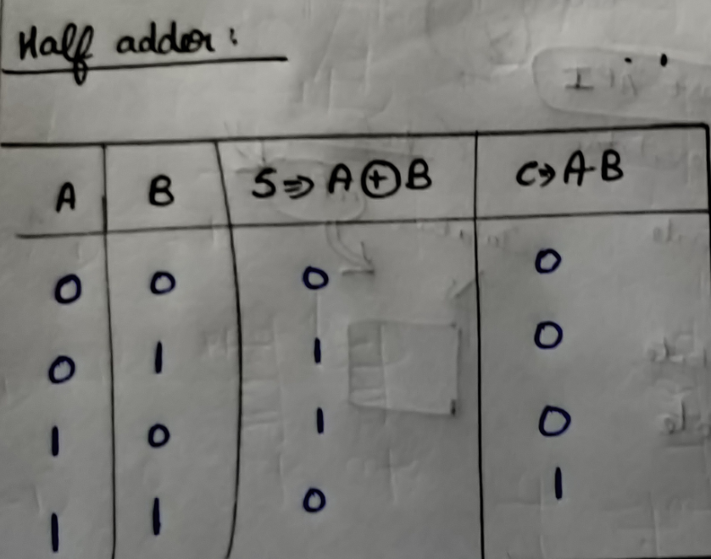

**Full – Adder**

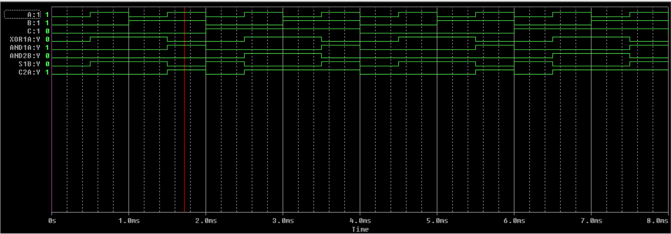

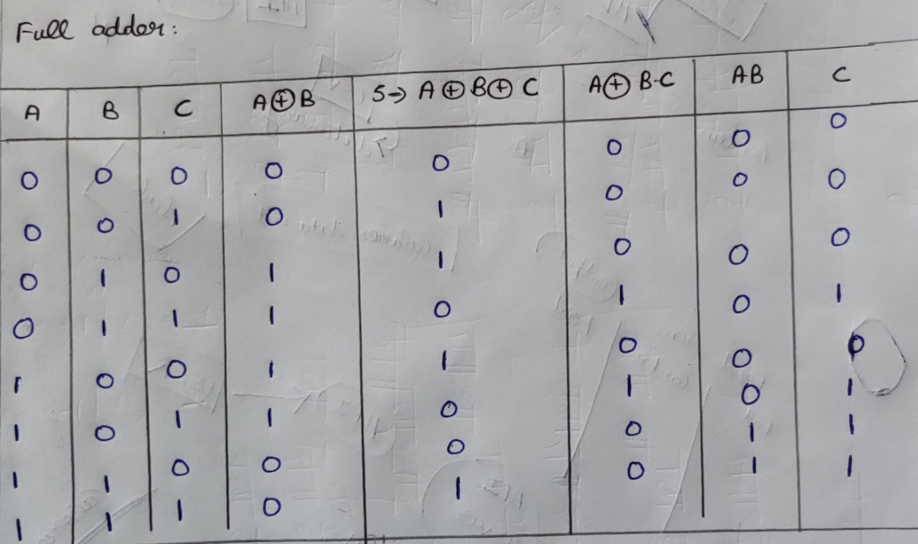

**Procedure:**

1. Draw the circuit diagram for half adder using the software ORCAD PCB DESIGNER LITE(offtime&ontime(1)=2ms ;offtime&ontime(2)=1ms )
2. Place the voltage markers at the respective outputs
3. Create netlist and new simulation profile
4. Run the circuit
5. Similarly draw the circuit diagram for full adder(offtime&ontime(1,2,3)=4ms;2ms;1ms)
6. Place the voltage markers at the respective outputs
7. Create netlist and new simulation profile
8. Run the circuit

**Libraries needed: 7400**

**Source:digclock**

**Analysis type : time domain**

**Run to time (for half adder): 4ms**

**Run to time (for full adder):8ms**

**Result:**

The theoretical values and the simulated results are same for both half and full adders

**Inference:**

Hence the theoretical values and stimulated results are verified.

**Reg. No: 19MID0020 Name: Prashanth.S Date: 10-09-2020**